|  |  |  |
| --- | --- | --- |
| **BUT Info S4 TD 1 Maggie Borthwick** | **Digital Age Societal and Ethical Issues**  **Listening Comprehension (semi-technical)** | Logo horizontal couleur de l'IUT de Bayonne et du Pays Basque |

Ethical Dilemmas for Computer Users and Professionals.

**Task 1** In groups, discuss these issues.

* Which is more important: access to affordable software or intellectual property rights? How do we protect developers so that they have the necessary incentive to be creative?
* Is hacking always wrong? Creating viruses?
* Who is responsible when a computer system fails to perform as it is supposed to? What kind of warranty should there be and from whom?
* What information on a database should be private? When are they doing us a service by providing that information?
* How should health hazards in the workplace be handled? Should we allow employers to monitor employee activities?
* To what extent can we trust intelligent systems?

**Task 2** Look at the title of the following documentary. Try and imagine what it is about.

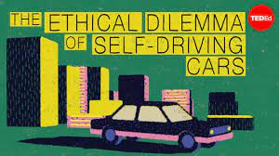

Watch the video **to 1 minute and 17 seconds**

[**https://www.youtube.com/watch?v=ixIoDYVfKA0**](https://www.youtube.com/watch?v=ixIoDYVfKA0)

**Questions**

1. List the different conditional (containing “if”) sentences and questions you hear.
2. Do you agree with the speaker’s conclusion?

**HMK**: Watch the rest of the film and be ready to discuss its contents.